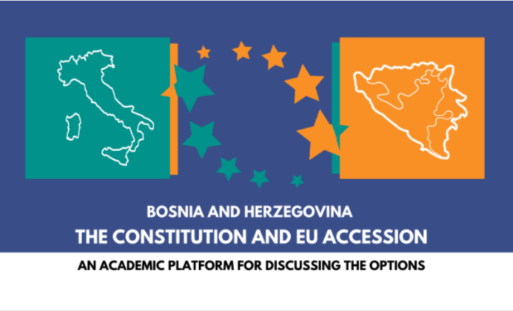 | CEI Knowledge Exchange Project Italy  Final conference  University of Sarajevo  Wednesday, 12 April 2023  Rectorate, Obala Kulina bana 71/II

BOSNIA AND HERZEGOVINA:
CONSTITUTION AND EU ACCESSION

09.00 Registration of the participants.
9.15 Opening of the Conference and Welcome by
Prof. dr Rifat Škrijelj, Rector of the University of Sarajevo
Prof. dr Amila Ždralović, Vice-Dean of the Faculty of Law, University of Sarajevo
HE Marco Di Ruzza, Ambassador of the Republic of Italy

9.30 Introduction to the CEI KEP BiH project by
Lejla Balić, University of Sarajevo and
Jens Woelk, University of Trento

10.00 – 11.30 First session
Values, principles, rights and duties for a functional system
of multi-level governance in BiH

Damir Banović, University of Sarajevo
Basic values, normative principles, and constitutionally guaranteed rights and duties for a functional system of multi-level governance and multicultural society

Dražen Barbarić, University of Mostar
The false dilemma of B&H constitutionalism

Discussant: Joseph Marko, University of Graz

Chair: Luisa Chiodi, Osservatorio dei Balcani, Caucaso e Transeuropa

11.30 – 12.00 Coffee break

12.00 – 13.30 Second session
Institutional organization of political representation and participation
in Bosnia and Herzegovina

Maja Sahadžić, Utrecht University and Samir Forić, University of Sarajevo
Complex state (Složena država): Sub-national autonomy vs. the central level

Lejla Balić, University of Sarajevo
Bicameralism in BiH - problems and perspectives

Discussant: Bojan Vlaški, University of Banja Luka
Intergovernmental relations in Bosnia and Herzegovina - as a possible instrument of effective federal system

Chair: Tatjana Sekulić, University of Milano-Bicocca

END OF THE PUBLIC CONFERENCE

13.30 – 15.00 Lunch break

15.00 Presentation of the publication

“Citizens. Constitution. Europe.
Glossary of essential constitutional concepts in BiH”

Editors:
Maja Sahadžić, Utrecht University
Damir Banović, University of Sarajevo
Dražen Barbarić, University of Mostar
Goran Marković, University of East Sarajevo

Introduction:
Maja Sahadžić, Utrecht University

16.00 – 16.30 Coffee break

16.30 – 18.00 Round table
(Participation of the project network members, Chatham House Rules)

Territorial and institutional organization
in the light of consociational and federal principles
Discussion on major controversial problems

Underlying question:
Is a divided society a “fact”? Corporate power sharing vs de-ethnification

Consequences:
Which kind of representation in the institutions (horizontal separation of powers)?
Ethno-national or territorial federalism (vertical division of powers)?

Introduction:
Joseph Marko, University of Graz
Samir Forić, University of Sarajevo
Goran Marković, University of East Sarajevo
Maja Sahadžić, University of Utrecht

Discussant: Neven Andjelić, Regent’s University, London
Chair: Jens Woelk, University of Trento and Tatjana Sekulić, University of Milano-Bicocca

19.30 – Social dinner for the project network members

SECOND DAY OF THE CONFERENCE, 13 April 2023, Faculty of Law

9.30-13.00 Workshop with young scholars/teaching assistants from the partner Universities.

Starting point for the discussion - underlying question:
Is a divided society a “fact”? Corporate power sharing vs de-ethnification

Consequences:
Which kind of representation in the institutions (horizontal separation of powers)?
Ethno-national or territorial federalism (vertical division of powers)?

The project is co-financed by the CEI Know-how Exchange Programme financed by Italy through the CEI Fund at the EBRD.

Partner Universities and Institutions:
University of Milano-Bicocca (coordinator of the project)
University of Trento
EURAC, Bozen/Bolzano
University of Sarajevo
University of East Sarajevo
University of Mostar
University of Banja Luka
Osservatorio dei Balcani, Caucaso e Transeuropa

In cooperation with the University of Graz and the Utrecht University

